**Magento Plugin**

**Version :**

Bhartipay Plugin version V1.0

Magento supported version 1.5.x – 1.9.x

**Installation and Configuration:**

1. Place all files to the relevant folder .

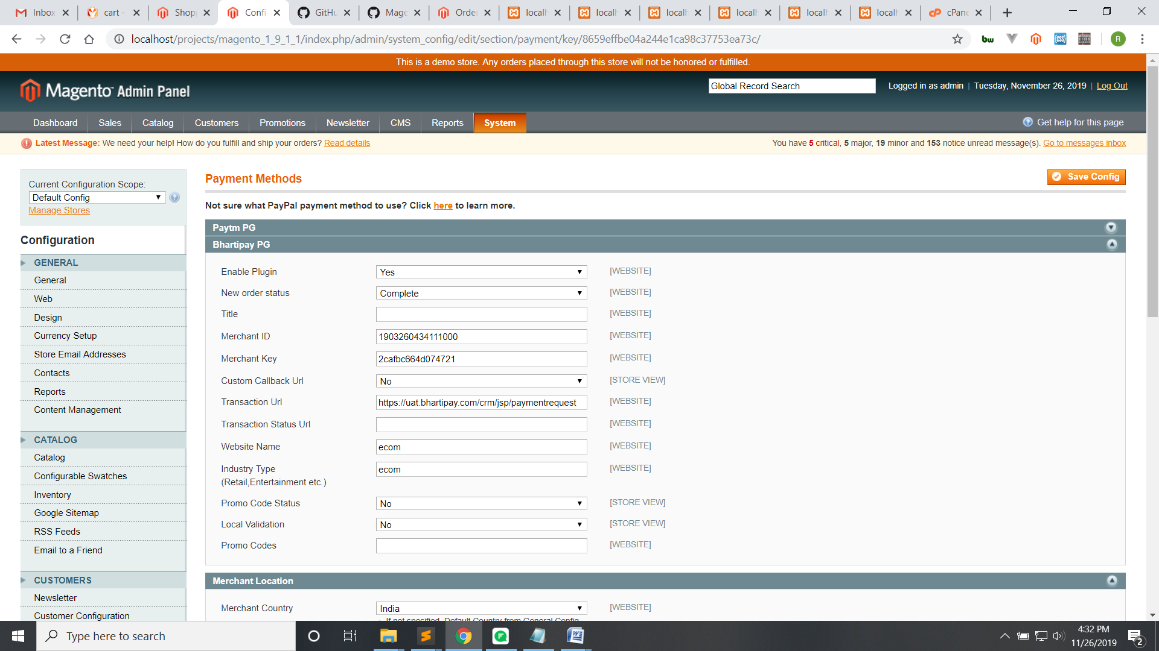

3)These are test Credentials.